**Employee Table**

* **Create Query:**

**Create Employee table with attributes EMPNO (PK), ENAME for employee name, JOB for employee designation, HIREDATE and SALARY.**

CREATE TABLE EMPLOYEE

(EMPNO NUMBER(4) PRIMARY KEY,

ENAME VARCHAR2(15),

JOB VARCHAR2(20),

HIREDATE DATE,

SALARY NUMBER(7, 2));

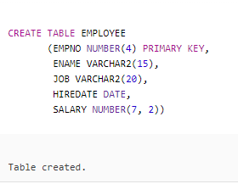

* **Insert Queries:**

INSERT INTO EMPLOYEE VALUES

(7369, 'ADEEL MIRZA', 'ACCOUNTS OFFICER',

TO_DATE('17-JAN-2012', 'DD-MON-YYYY'), 28000);

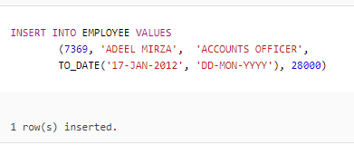

INSERT INTO EMPLOYEE VALUES

(7543, 'MUHAMMAD KAMRAN ', 'RECEPTIONIST',

TO_DATE('1-JAN-2017', 'DD-MON-YYYY'), 20500);

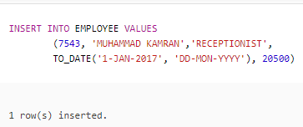

INSERT INTO EMPLOYEE VALUES

(7589, 'SHANZAY KHAN', 'RECEPTIONIST',

TO_DATE('3-JAN-2018', 'DD-MON-YYYY'), 18500);

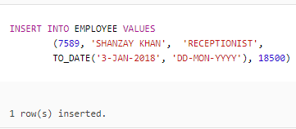

INSERT INTO EMPLOYEE VALUES

(7312, 'FURQAN ALI', 'OFFICE BOY',

TO_DATE('27-APR-2015', 'DD-MON-YYYY'), 10000);

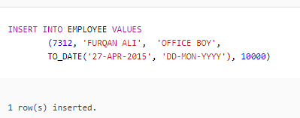

INSERT INTO EMPLOYEE VALUES

(7789, 'DAUD AKRAM', 'SECURITY GUARD',

TO_DATE('21-FEB-2014', 'DD-MON-YYYY'), 13000);

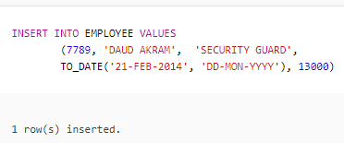

INSERT INTO EMPLOYEE VALUES

(7384, 'ALI RAZA', ‘OFFICE BOY',

TO_DATE ('17-JAN-2014', 'DD-MON-YYYY'), 11000);

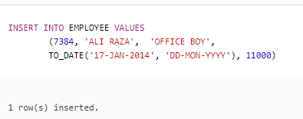

INSERT INTO EMPLOYEE VALUES

(7987, 'ANWAR ALI', 'ELECTRICIAN',

TO_DATE('20-AUG-2014', 'DD-MON-YYYY'), 15000);

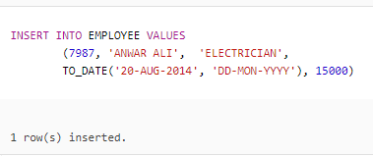

* **Delete Queries:**



**Delete a row from Employee table having EMPNO 7160.**

DELETE FROM EMPLOYEE

WHERE EMPNO = 7160;

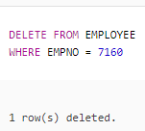



**Delete a row from Employee table having EMPNO 7309.**

DELETE FROM EMPLOYEE

WHERE EMPNO = 7309;

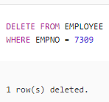



**Delete a row from Employee table having EMPNO 7267.**

DELETE FROM EMPLOYEE

WHERE EMPNO = 7267;

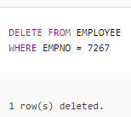



**Delete a row from Employee table having EMPNO 7165.**

DELETE FROM EMPLOYEE

WHERE EMPNO = 7165;

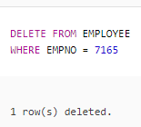



**Delete a row from Employee table having EMPNO 7987.**

DELETE FROM EMPLOYEE

WHERE EMPNO = 7987;

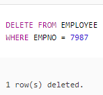

* **Update Queries:**



**Change receptionist name as HANIA QURESHI where EMPNO is 7589.**

UPDATE EMPLOYEE

SET ENAME = 'HANIA QURESHI'

WHERE EMPNO = 7589;

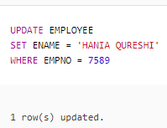



**Update the Salary from 7000 to 8000 where EMPNO is 7212.**

UPDATE EMPLOYEE

SET SALARY = 8000

WHERE EMPNO = 7212;

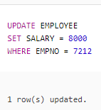



**Salary of an employee having EMPNO 7369 is increased and his EMPNO is changed. His new salary is 30000 and new EMPNO is 7370.**

UPDATE EMPLOYEE

SET SALARY = 30000, EMPNO = 7370

WHERE EMPNO = 7369;

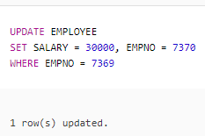



**Correct the spelling of an Employee “ALI RAZA” having EMPNO 7384. Write “ALEE RAZA”.**

UPDATE EMPLOYEE

SET ENAME = 'ALEE RAZA'

WHERE EMPNO = 7384;

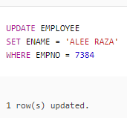



**An Employee having EMPNO 7543 is promoted as REEPTIONIST and his new salary is 26000.**

UPDATE EMPLOYEE

SET JOB = 'ACCOUNTS OFFICER', SALARY = 26000

WHERE EMPNO = 7543;

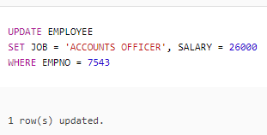

* **Other Queries:**



**Display name, hire date and day of hiring of employee as “DAY”.**

SELECT ENAME, HIREDATE, TO_CHAR (HIREDATE, ‘DAY’) “DAY”

FROM EMPLOYEE;

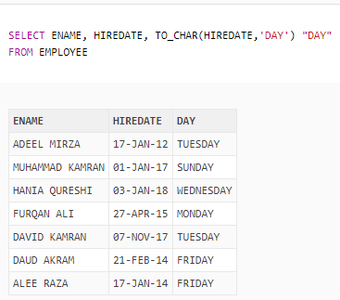

**Show name, employee number, job, hire date, annual salary as “YEARLY SALARY” and 15% of annual salary as “BONUS PER YEAR” of those employees whose hire date is greater than 20-DEC-2015 and name contains A or E and salary between 10000 and 30000 and job is not ACCOUNTS OFFICER or OFFICE BOY. Display hire date in descending order and employee name in ascending order.**

SELECT ENAME, EMPNO, JOB, HIREDATE, SALARY * 12 “YEARLY SALARY”, (SALARY * 12) * 0.15 “BONUS PER YEAR”

FROM EMPLOYEE

WHERE HIREDATE > ’20-DEC-2015’

AND (ENAME LIKE ‘%A%’ OR ENAME LIKE ‘%E%’)

AND SALARY BETWEEN 10000 AND 30000

AND JOB NOT IN (‘ACOUNTS OFFICER’, ‘OFFICE BOY’)

ORDER BY HIREDATE DESC, ENAME ASC;

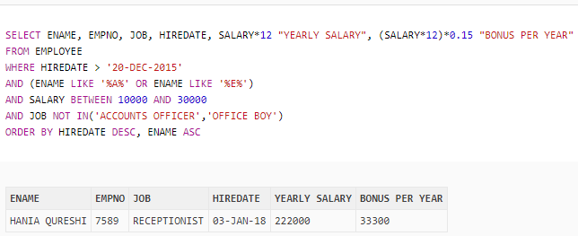

**Give name, salary and hire date of those employees whose employee number between 7200 and 7500 or job is SECURITY GUARD and salary is greater than 5000.**

SELECT ENAME, SALARY, HIREDATE

FROM EMPLOYEE

WHERE EMPNO BETWEEN 7200 AND 7500

OR (JOB = ‘SECURITY GUARD’

AND SALARY > 5000);

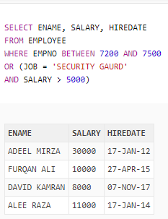

**Give name and salary of those employees who have A in last of their names and job is SWEEPER.**

SELECT ENAME, SALARY

FROM EMPLOYEE

WHERE ENAME LIKE ‘%A’

AND JOB = ‘SWEEPER’;

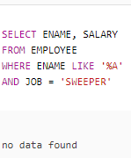

**Display employee number, name and hire date of those employees who have salary greater than 10000 and job is RECEPTIONIST or ACOUNTS OFFICER.**

SELECT EMPNO, ENAME, HIREDATE

FROM EMPLOYEE

WHERE SALARY > 10000

AND (JOB = ‘RECEPTIONIST’

OR JOB = ‘ACCOUNTS OFFICER’);

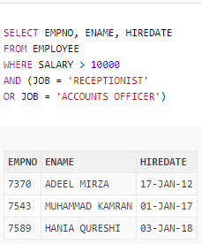

**Show employee number, name, hire date and salary of those employees who have double A or A and R in their names.**

SELECT EMPNO, ENAME, HIREDATE, SALARY

FROM EMPLOYEE

WHERE ENAME LIKE ‘%A%A%’

OR ENAME LIKE ‘%A%R%’;

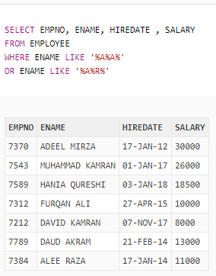

**Give name, hire date and salary of those employees who hired after 20-FEB-2017 and salary is greater than 15000 and employee number is 7212 or 7370;**

SELECT ENAME, HIREDATE, SALARY

FROM EMPLOYEE

WHERE HIREDATE > ’20-FEB-2017’

AND SALARY > 15000

AND EMPNO IN (7212, 7370);

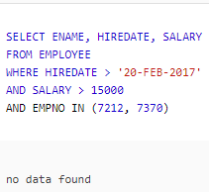

**Display all record of those employees whose salary is in between 5000 and 10000 and hire date is less than 1-DEC-2015.**

SELECT *

FROM EMPLOYEE

WHERE SALARY BETWEEN 5000 AND 10000

AND HIREDATE < ‘1-DEC-2015’;

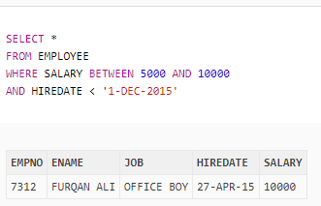

**Display name, employee number, job and hire date of all those employees who hired before 20-AUG-2018 and salary is greater than 18000 and job is not accounts officer or manager. Output in ascending order of hire date.**

SELECT ENAME, EMPNO, JOB, HIREDATE

FROM EMPLOYEE

WHERE HIREDATE < ’20-AUG-2015’

AND SALARY > 18000

AND JOB NOT IN (‘ACCOUNTS OFFICER’, ‘MANAGER’)

ORDER BY HIREDATE;

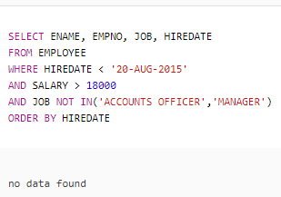

**Show Cartesian product of employee and hall where hall id is greater than 5005.**

SELECT *

FROM EMPLOYEE, HALL

WHERE ID > 5005;

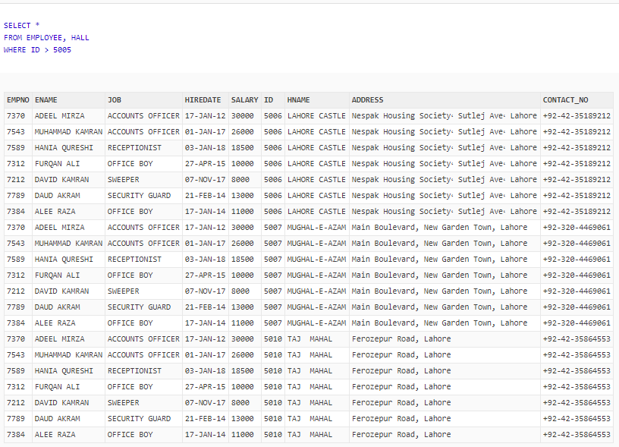

**Show name, hire date and job of all those employees whose half salary is greater than 7000 or who hired before 12-JAN-2016 and contain U in their names.**

SELECT ENAME, HIREDATE, JOB

FROM EMPLOYEE

WHERE ((SALARY/2) > 7000

OR HIREDATE < ’12-JAN-2016’)

AND ENAME LIKE ‘%U%’;

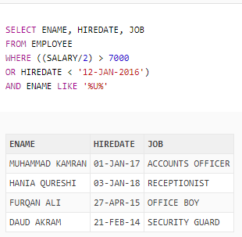

**Show name, job and salary of all those employees who is not SWEEPER or ELECTRICIAN and salary is greater than or equal to 13000 and contains C at third position of their jobs.**

SELECT ENAME, JOB, SALARY

FROM EMPLOYEE

WHERE JOB NOT IN (‘SWEEPER’, ELECTRICIAN’)

AND SALARY >= 13000

AND JOB LIKE ‘__C%’;

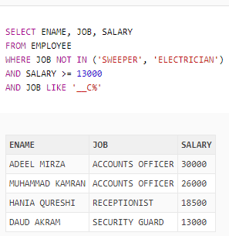

**Give employee number, name, hire date and salary of all those employees whose employee number is 7384.**

SELECT EMPNO, ENAME, HIREDATE, SALARY

FROM EMPLOYEE

WHERE EMPNO = 7384;

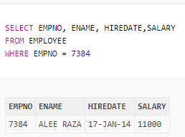

**Show all record of those employees whose salary is less than 10000 and have A in their names and job is no ELECTRICIAN and hired after 23-NOV-2014.**

SELECT *

FROM EMPLOYEE

WHERE SALARY < 10000

AND ENAME LIKE ‘%A%’

AND JOB <> ‘ELECTRICIAN’

AND HIREDATE > ’23-NOV-2014’;

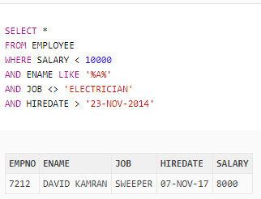

**Display all record of those employees who have employee number 7312.**

SELECT *

FROM EMPLOYEE

WHERE EMPNO = 7312;

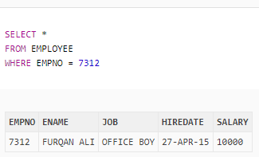

* **Function Queries:**

**Show employee number as “EMPLOYEE NUMBER”, name as “EMPLOYEE NAME”, hire date , salary and incremented salary as “INCREMENTED SALARY” with these conditions:**

* **If the employee is working as ‘ACCOUNTS OFFICER’, add 10% to salary.**
* **If the employee is working as ‘RECEPTIONIST’, add 8% to salary.**
* **If the employee is working as ‘ELETRICIAN’, add 7% to salary.**
* **If the employee is working as ‘SECURITY GAURD’, add 5% to salary.**
* **If the employee is working as ‘OFFICE BOY’, add 6% to salary.**
* **If the employee is working as ‘SWEEPER’, add 4% to salary.**

SELECT EMPNO “EMPLOYEE NUMBER”, ENAME “EMLOYEE NAME, HIREDATE, SALARY,

CASE JOB WHEN ‘ACCOUNTS OFFICER’ THEN (SALARY * 0.10) + SALARY

WHEN ‘RECEPTIONIST’ THEN (SALARY * 0.08) + SALARY

WHEN ‘ELECTRICAIAN’ THEN (SALARY * 0.07) + SALARY

WHEN ‘SECURITY GUARD’ THEN (SALARY * 0.05) + SALARY

WHEN ‘OFFICE BOY’ THEN (SALARY * 0.06) + SALARY

WHEN ‘SWEEPER’ THEN (SALARY * 0.04) + SALARY

ELSE SALARY END “INCREMENTED SALARY”

FROM EMPLOYEE;

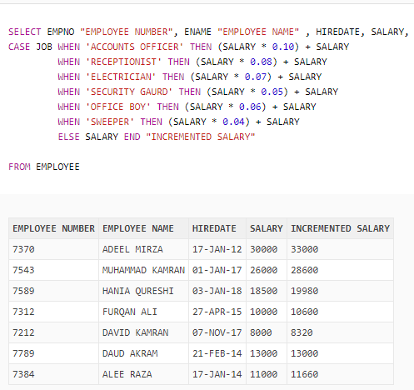

**Show name, hire date, round months between current date and hire date as “MONTHS” and length of name of all employees as “LENGTH”.**

SELECT ENAME, HIREDATE, ROUND (MONTHS_BETWEEN (SYSDATE, HIREDATE)) “MONTHS”, LENGTH (ENAME) “LENGTH”

FROM EMPLOYEE;

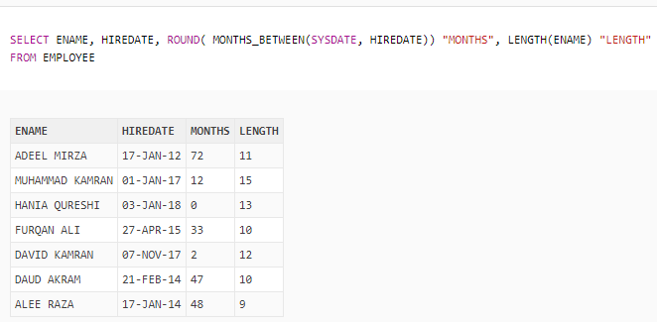

**Show name and location of A in employee name as “LOCATION OF A”**

SELECT ENAME, INSTR (ENAME, ‘A’) “LOCATION OF A”

FROM EMPLOYEE;

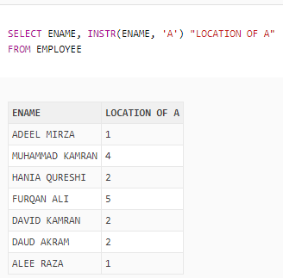

* **Sub-Queries:**

**Show complete record of those employees whose job is same as ADEEL MIRZA job and salary is 26000 and have 4 A in their names.**

SELECT *

FROM EMPLOYEE

WHERE JOB = ALL (SELECT JOB

FROM EMPLOYEE

WHERE ENAME = ‘ADEEL MIRZA’)

AND SALARY = 26000

AND ENAME LIKE ‘%A%A%A%A%’;

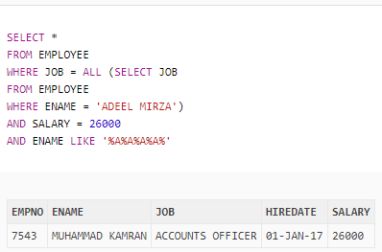

**Give employee number of all those employees who have employee number greater than employee number of HANIA QURESHI.**

SELECT EMPNO

FROM EMPLOYEE

WHERE EMPNO > (SELECT EMPNO

FROM EMPLOYEE

WHERE ENAME = ‘HANIA QURESHI’);

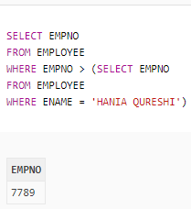

**Show all record of all employees whose salary is greater than the salary of DAUD AKRAM.**

SELECT *

FROM EMPLOYEE

WHERE SALARY > (SELECT SALARY

FROM EMPLOYEE

WHERE ENAME = ‘DAUD AKRAM’);

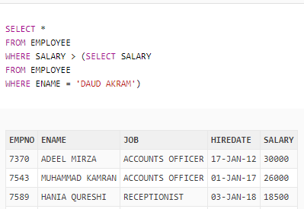

**Table**

